American International University-Bangladesh (AIUB)

Title of the research
Subtitle goes here

full name (xx-xxxxx-x) full name (xx-xxxxx-x) full name (xx-xxxxx-x) full name (xx-xxxxx-x)

A Thesis submitted for the degree of Bachelor of Science (BSc) in Computer Science and Engineering (CSE) at
American International University Bangladesh in July, 2021
Faculty of Science and Technology (FST)

Abstract
(All candidates must edit this page )

The abstract should outline the main approach and findings of the thesis / software project and normally must be between 300 and 800 words.
An abstract is a summary of your entire thesis and should provide a complete overview of the thesis, including your key results and findings.
An abstract is different to your introduction, and shouldn’t be used to advertise your thesis — it should provide enough information to allow readers to understand what they’ll learn by reading the thesis.
Your abstract should answer the following questions:

- What did you do?

- How did you do it?

- Why was it worth doing?

- What were the key results?

- What are the implications or significance of the results?

As your abstract will have a word limit, you may be unable to answer every question in detail. If you find yourself running out of words, make sure you include your key findings before other information.

Declaration by author
(All candidates to reproduce this section in their thesis verbatim)

This thesis is composed of our original work, and contains no material previously published or written by another person except where due reference has been made in the text. We have clearly stated the contribution of others to our thesis as a whole, including statistical assistance, survey design, data analysis, significant technical procedures, professional editorial advice, financial support and any other original research work used or reported in our thesis. The content of our thesis is the result of work we have carried out since the commencement of Thesis / Software project.

We acknowledge that copyright of all material contained in my thesis resides with the copyright holder(s) of that material. Where appropriate we have obtained copyright permission from the copyright holder to reproduce material in this thesis and have sought permission from co-authors for any jointly authored works included in the thesis.

Name of the Author 1  Student ID  Computer Science & Engineering  Faculty of Science & Technology |  | Name of the Author 2  Student ID  Computer Science & Engineering  Faculty of Science & Technology
Name of the Author 3  Student ID  Computer Science & Engineering  Faculty of Science & Technology |  | Name of the Author 4  Student ID  Computer Science & Engineering  Faculty of Science & Technology

Approval
(All candidates must edit this page )

The thesis titled “Thesis title goes here” has been submitted to the following respected members of the board of examiners of the department of computer science in partial fulfilment of the requirements for the degree of Master of Science in Computer Science on (date of defence) and has been accepted as satisfactory.

Supervisor’s Name  Rank & Position |  |  | Name of the External  Rank & Position
Name of the Head (UG/PG)
Rank & Position

Prof. Dr. Dip Nandi  Associate Dean  Faculty of Science and Technology  American International University-Bangladesh |  |  | Mashiour Rahman  Sr. Associate Professor & Dean-in-charge  Faculty of Science and Technology  American International University-Bangladesh

Publications included in this thesis

If you choose to include publications as part of your thesis use this section to detail accepted or in press publication(s) using the standard citation format for your discipline.

Papers submitted for publication and awaiting review should appear in the next section, Submitted manuscripts included in this thesis.

If you have not included any of your publications in the thesis then state “No publications included”.

Example:

- [Dum, 2021] Your Name, Co-author 1, and Final Author, Title of your paper, Journal, Issue, Number, Year
- [Dum, 2021] Your Name, Co-author 1, and Final Author, Title of your paper, Journal, Issue, Number, Year

Submitted manuscripts included in this thesis
List manuscript/s submitted for publication here. As described above for Publications included in the thesis, on the page immediately preceding the chapter that includes the submitted manuscript, in no more than one (1) page, detail your contribution to the authorship if you are not the sole author.

If you have no submitted manuscripts from your candidature then state “No manuscripts submitted for publication”.

Example:

1. [Dum, 2021] Your Name, Co-author 1, and Final Author, Title of your paper, submitted to
Journal on 4th June 2018.

Other publications during candidature
List other publications arising during your candidature using the standard citation format for your dis- cipline. Divide your publications into sub-sections as appropriate in your discipline e.g. peer-reviewed papers, book chapters, conference abstracts. Papers submitted for publication and awaiting review are not considered publications and cannot be included in this section.
If you have no publications from your candidature then state “No other publications”.

Example:

Conference abstracts
1. [Dum, 2021] Your Name, Co-author 1, and Final Author, Title of your conference paper,
Proceedings of Conference, other details.

Book chapters
1. [Dum, 2021] Your Name, Co-author 1, and Final Author, Title of your chapter, Book, editor,
etc..

Research involving human or animal subjects
All reserch involving human or animal subjects requires prior ethical review and approval by an independent review committee. At UQ, the relevant committee for research involving human subjects is the Human Ethics Unit and the relevant committee for research involving animal subjects is the relevant Animal Ethics Committee. Please provide details of any ethics approvals obtained including the ethics approval number and name of approving committees. A copy of the ethics approval letter must be included in the thesis appendix.

If no human or animal subjects were involved in this research please state: “No animal or human subjects were involved in this research”.

Contributions by authors to the thesis
List the significant and substantial inputs made by different authors to this research, work and writing represented and/or reported in the thesis. These could include significant contributions to: the conception and design of the project; non-routine technical work; analysis and interpretation of research data; drafting significant parts of the work or critically revising it so as to contribute to the interpretation.
 | Full Name | Full Name | Full Name | Full Name | Contribution (%)
 | xx-xxxxx-x | xx-xxxxx-x | xx-xxxxx-x | xx-xxxxx-x
Conceptualization |  |  |  |  | 100 %
Data curation |  |  |  |  | 100 %
Formal analysis |  |  |  |  | 100 %
Investigation |  |  |  |  | 100 %
Methodology |  |  |  |  | 100 %
Implementation |  |  |  |  | 100 %
Validation |  |  |  |  | 100 %
Theoretical derivations |  |  |  |  | 100 %
Preparation of figures |  |  |  |  | 100 %
Writing – original draft |  |  |  |  | 100 %
Writing – review & editing |  |  |  |  | 100 %

If your task breakdown requires further clarification, do so here. Do not exceed a single page.

Acknowledgments

Acknowledgements recognize those who have been instrumental in the completion of the project. Acknowledgements should include any professional editorial advice received including the name of the editor and a brief description of the service rendered.

Keywords
Maximum 10 words; use lower case throughout, separating words/phrases with commas. For example: word, word word, word, word, word word

Table of Contents
Title of the research i
Abstract ii
Declaration by author iii
Approval iv
Publications included in this thesis v
Submitted manuscripts included in this thesis v
Other publications during candidature vi
Conference abstracts vi
Book chapters vi
Research involving human or animal subjects vi
Contributions by authors to the thesis vii
Acknowledgments viii
Keywords ix
List of Tables xii
List of Abbreviations and Symbols xiv
Introduction 1
1.1 Your thesis topic 1
Literature review 3
2.1 Introduction 3
Methods 6
3.1 Introduction 8
Results or findings 9
4.1 Introduction 9
Discussion 12
5.1 Introduction 12
Conclusion 14
Bibliography 16
Appendix 18
A.1 Name of Appendix-1 18
Example of Citations 21
Example of Equations 23
Example of Figures 25
Example of Tables 27
Example of algorithm procedure 30
Example of Code 33
G.1 Find the greatest number from a list of numbers in Python 33

List of Figures

Figure D. 1 : American International University-Bangladesh (AIUB) 36
Figure D. 2: Example of placing images side by side 38

List of Tables

Table E. 1: AIUB currently operates under four distinct Faculties x 41
Table E. 2: Row span example 41
Table E. 3 : Test Table 41

List of Abbreviations and Symbols

Mention all the abbreviations and the different symbols that is used in this document.

Abbreviations

CS Computer Science
CSE Computer Science and Engineering
NN Neural Network
HCI Human Computer Interaction
NLP Natural Language Processing
etc. etc.

Symbols
ρˆ Density operator
® Convolution
etc. etc.

Chapter 1

Introduction

This chapter is critical as it is the first thing that the examiner will read and it is therefore important to make a good first impression. A sample structure of writing a thesis introduction is given bellow.
    - Capture reader’s interest - Initially you need to capture the reader’s attention with a discussion of a broader theme relating to your research. To add impact draw on research, data and quotations from international or national professional bodies, governmental organisations or key authors on the topic of study.
    - General aims – what you intend to contribute to the understanding of a topic

    - Specific objectives – You must then sell your idea for undertaking the research topic, demonstrat- ing the main reasons why the research will make a significant contribution to the current body of research. This can be achieved by demonstrating a gap or limitation with existing research, then showing how your research will resolve this.
    - List your research questions - You need to include a list of research questions that is going to be answered through the findings of this research. Generally, three or four overarching research objectives should be pointed out as research questions.
    - Provide an overview of the forthcoming chapters - The final part of the introduction should provide a glimpse of the structure of your thesis book and also an overview of the rest of the chapters.
    - Your Introduction must not exceed two pages.

1.1 Your thesis topic
Introduce your topic.

Chapter 2

Literature review

The literature review should provide a more detailed analysis of research in the field, and present more specific aims or hypotheses for your research. What’s expected for a literature review varies depending on your program – a Master’s thesis requires a more extensive literature review than a BSC thesis.

Introduce the broad layout of the chapter.

Introduction
Add your text here.

Chapter 3

Methods

A possible structure for your methods section is to include an introduction that provides a justification and explanation of the methodological approach you chose, followed by relevant sub-sections. Some standard sub-sections of a methods chapter include:

    - Design

    - Participants

    - Materials

    - Procedures

How the methods section is structured can depend on your discipline, so consult your thesis supervisor for ideas for structure.
Regardless of structure, the methods section should explain:

- how you collected and analysed your data – you only need to include enough detail that another expert in the field could repeat what you’ve done (you don’t have to detail field standard techniques or tests)
- why you chose to collect specific data

- how this data will help you to answer your research questions

- why you chose the approach you went with.

Introduce the broad layout of the chapter.

6 CHAPTER 3. METHODS

Introduction
Add your text here.

Chapter 4

Results or findings

Use the results section to:

    - specify the data you collected and how it was were prepared for analysis

    - describe the data analysis (e.g. define the type of statistical test that was applied to the data)

    - describe the outcome of the analysis

    - present a summary and descriptive statistics in a table or graph.

Use tables and figures effectively
Reports usually include tables, graphs and other graphics to present data and supplement the text. To learn how to design and use these elements effectively, see examples provided in Appendix B (D, E, C, F).

Introduce the broad layout of the chapter.

Introduction
Add your text here.

Chapter 5

Discussion

Use the discussion section to:

        - comment on your results and explain what they mean

        - compare, contrast and relate your results back to theory or the findings of other studies

        - identify and explain any unexpected results

        - identify any limitations to your research and any questions that your research was unable to answer
        - discuss the significance or implications of your results.

        - If you find that your research ends up in a different direction to what you intended, it can help to explicitly acknowledge this and explain why in this section.

Introduce the broad layout of the chapter.

Introduction
Add your text here.

Chapter 6

Conclusion

Use the conclusion section to:

    - summarise the main findings of your research

    - emphasise that you’ve met your research aims. A good strategy is to repeat your research questions and demonstrate how your findings answer them.
    - restate the limitations of your research and make suggestions for further research.

In some cases, the discussion and conclusion sections can be combined. Check with your supervisor if you want to combine these sections. your conclusion chapter should not exceed two pages.

Conclude your thesis.

Bibliography

[Dum, 2021] (2021). Demo title.

[Hasan et al., 2013] Hasan, K. T., Abdullah, S. S., Ahmed, R., and Giunchiglia, F. (2013). The history of temporal data visualization and a proposed event centric timeline visualization model. International Journal of Computer Applications, 70(27).
[Hasan et al., 2021] Hasan, K. T., Rahman, M. M., Ahmmed, M. M., Chowdhury, A. A., and Islam,
M. K. (2021). 4p model for dynamic prediction of covid-19: a statistical and machine learning approach. Cognitive Computation, pages 1–14.
[Nandi et al., 2012] Nandi, D., Hamilton, M., and Harland, J. (2012). Evaluating the quality of interaction in asynchronous discussion forums in fully online courses. Distance education, 33(1):5– 30.
[Nandi et al., 2011] Nandi, D., Hamilton, M., Harland, J., and Warburton, G. (2011). How active are students in online discussion forums? In Proceedings of the Thirteenth Australasian Computing Education Conference-Volume 114, pages 125–134.

Appendix A

Appendix

Write your appendix here. Following two are examples.

Name of Appendix-1

  - Name of Appendix-2

Appendix B

Example of Citations

This text is only for Bibliography testing purposes.
Dr. Dip Nandi currently works as an Associate Professor and the Director of Faculty of Science and Technology in American International University-Bangladesh (AIUB). His research area includes: Software Engineering, E-Learning Technologies, Data Mining and Information systems and has produced several publications in these domains [Nandi et al., 2012, Nandi et al., 2011].
Dr. Tabin Hasan primarily focuses in the research Domain of Human Computer Interaction. He is been a active researcher for more than a decade and produced many high quality journals [Hasan et al., 2013], conferences [Hasan et al., 2021] and book chapters.

Appendix C

Example of Equations

The well known Pythagorean theorem x² + y² = z² was proved to be invalid for other exponents. Meaning the next equation has no integer solutions:

x^{n} + y^{n} = z^{n}
The ampersand character & determines where the equations align. Let’s check a more complex example:
x = y w = z a = b + c
2x = y 3w = 1 z a = b
−
2
−4 + 5x = 2 + y w + 2 = −1 + w ab = cb
The mass-energy equivalence is described by the famous equation

E = mc²
discovered in 1905 by Albert Einstein. In natural units (c = 1), the formula expresses the identity

Some random examples ...
E = m (C.1)

∞ 1 1

∑ ns = ∏ 1 − p−s (C.2)
i=1 p
∞
∑ 2^{−n} = 1 (C.3)
n=1

V µ(t, u, v, w) dt dudvdw (C.4)

Appendix D

Example of Figures

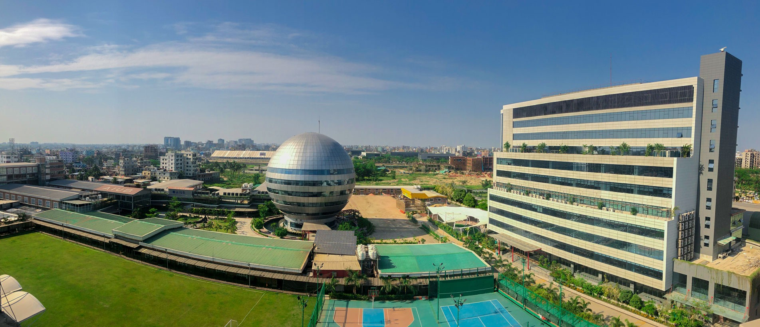
Figure D. 1 : American International University-Bangladesh (AIUB)

The Figure D.1 represents beauty of the AIUB campus.

APPENDIX D. EXAMPLE OF FIGURES
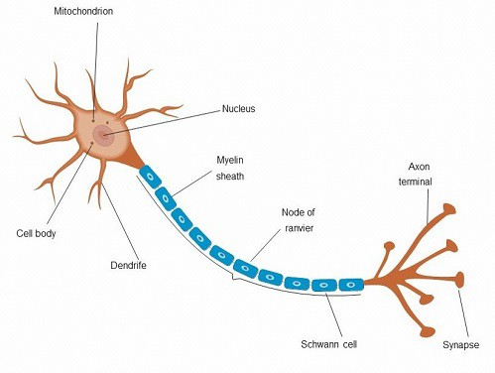
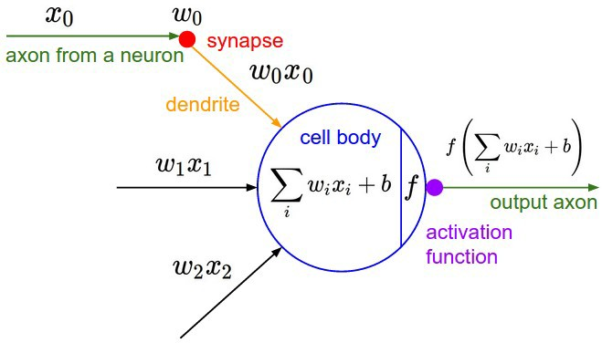
- Anatomy of a multipolar neuron (b) Architecture of a artificial neuron

Figure D. 2: Example of placing images side by side

Appendix E

Example of Tables

Here is a really simple table E.1.

Table E. 1: AIUB currently operates under four distinct Faculties x

Number | Name
1 | Faculty of Science and Technology (FST)
2 | Faculty of Engineering (FE)
3 | Faculty of Business Administration (FBA)
4 | Faculty of Arts and Social Sciences (FASS)

Here is another example of table row merged E.2.

Table E. 2: Row span example

col1 | col2 | col3
Multiple row | cell2  cell5 cell8 | cell3  cell6 cell9

Here is another example of controlling table width E.3.

Table E. 3 : Test Table

One | Two | Three | Four | Five | Six | Seven | Eight | Nine | Ten | Eleven | Twelve | Thirteen | Fourteen
1.111 | 2.222 | 3.333 | 4.444 | 5.555 | 6.666 | 7.777 | 8.888 | 9.999 | 0.000 | 1.111 | 2.222 | 3.333 | 4.444

Appendix F

Example of algorithm procedure

Algorithm 1: Example code
Input: A graph G Output: A vertex of G Data: Testing set x

∞
1 ∑
i=1
:= 0 // this is a comment

/* Now this is an if...else conditional loop */
2 if Condition 1 then
3 Do something // this is another comment
4 if sub-Condition then
5 Do a lot

6 else if Condition 2 then
7 Do Otherwise
/* Now this is a for loop */
8 for sequence do
9 loop instructions

10 else
11 Do the rest
/* Now this is a While loop */
12 while Condition do
13 Do something

Example of writing algorithms is shown here 1.

Appendix G

Example of Code

G.1 Find the greatest number from a list of numbers in Python

a=[1,2,3,4,6,7,99,88,999]
max= 0
for i in a:
if i > max:
max=i print(max)

End quote goes here.

